Preparing IRIS Data
8 October 2025

The process of preparing IRIS data for analyses consists of downloading three data collections (from two sources), unpacking the data, and then joining the data frames.

Before Beginning

This process requires multiple applications on your local computer and accounts on two servers. You must have all of these in place before beginning.

Local Computer

I estimate the project will generate approximately 300 GB of Fitbit data, <10 MB of EMA data, and approximately 4 GB of audio data. Hence, one should have at least 400 GB of storage available on a local computer. (These are early estimates based on only two people and a few days of data. Hence, the confidence interval associated with these estimates is very wide. Better estimates will become available as time passes.)

- You will need to have Terminal (Mac) or an equivalent tool (such as PowerShell or Command Prompt) in Windows. These ship with the operating system. You can also use the Terminal in RStudio, which is what BPR does.
- You must have a data folder set up. The IRIS R scripts expect the following folder structure (although you can put them in whatever folder you want; BPR uses ~/IRIS_Data as the project folder on a Mac):
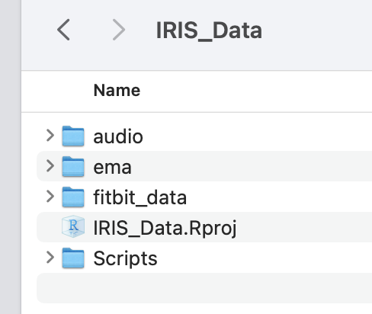
The IRIS_Data.Rproj file and Scripts folder were used to create the survey versions; you do NOT need to have those in your folder.
- BPR uses R/RStudio for data merging; other applications could also be used, but this process assumes that the work will be done in R/RStudio.
- Additionally, you will need a good speech-to-text engine. It appears that the R package will suffice, but others (e.g., SpeechRecognition in Python) may work better.

Accounts

- You must have an account on the server where the Fitbit data are housed; talk with Blake Lawyer or Terry Boullt to obtain an account.
- You must have access to the IRIS project mEMA account (in the name of Charles Benight).

Download Data

Begin by downloading data from the server where the Fitbit data are stored, as well as the server from which both the mEMA and audio data are stored. This procedure changed at the start of the Fall 2025 semester at UCCS.

Download Fitbit Data

- Scrape data from the server. In Terminal/Command Line, use the following Unix command (copy the whole thing and paste as a single command):

rsync -av --update --progress bricca@moodle.vast.uccs.edu:/opt/IRIS/uccs/fitbit/fitbit_data/ ~/IRIS_Data/fitbit_data

The previous command is for Barney Ricca’s Mac and can only be run from Barney Ricca’s MacMini. (It might work from on the UCCS campus, but that hasn’t been tested yet.) Contact Terry Boult to access the server from anywhere else. You may need to replace the ~/IRIS_Data with the folder/directory appropriate to your computer (see the file structure in the Merge Data below), and the bricca with your server account name if you aren’t using the default account. However, for now, “everyone” will use the bricca account. When prompted, you must enter the moodle.vast.uccs.edu account password; as you type the password, nothing will appear on the screen.

IF YOU AREN’T 100% CERTAIN THAT YOU KNOW WHAT YOU ARE DOING, DO NOT RUN ANY COMMANDS OTHER THAN THE ONE LISTED; THERE IS A RISK YOU COULD ERASE DATA.

The above command only downloads the data that have changed since the last download. Hence, the first time it is run, it will download all the data for each day; subsequent runs will download only the subset of data that were collected since the last scraping. On BPR’s computer, the download speed is about 25 MB/s. As of November 5, 2025, there are about 9 GB of data on the server, so a full download would probably take around 10 minutes; the weekly update took less than 30 seconds.

Downloading may be interrupted for various reasons; you may get a message like this in Terminal:

-Read from remote host moodle.vast.uccs.edu: Operation timed out client_loop: send disconnect: Broken pipe
scp: Connection closed

If that happens, repeat step 1. If it happens repeatedly, get tech help.

- After downloading the data, exit Terminal.

mEMA Data

There are two types of data from the mEMA app: the EMA data and the audio data. These are downloaded separately.

Download EMA Data

The data download process can be found online at:

https://ilumivu.freshdesk.com/support/solutions/articles/9000208850-rapid-report

- Go to https://mema.ilumivu.com and log in to the cbenight@uccs.edu account.

- Each of the 12 surveys must be downloaded separately. (At least, I haven’t found a way to download all 12 surveys at once.)

  - Begin by clicking on the “Survey Editor” (a.k.a., “Create Survey”) tool, which is the clipboard-looking object in the following picture:

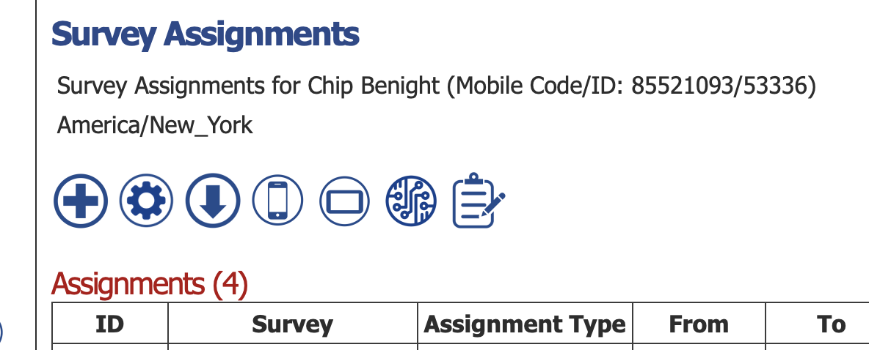

  - That will bring up the following:

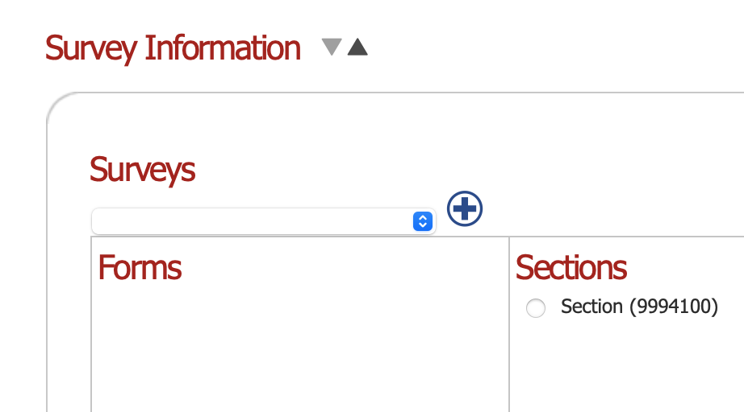

  - Click on the blue up/down arrow button to reveal all of the data:
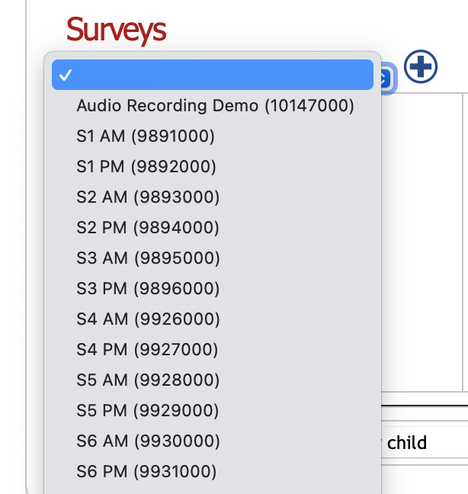

  - Choose the appropriate EMA survey (S1 AM through S6 PM); a pop-up window will briefly appear (and then disappear), and then the following will appear:

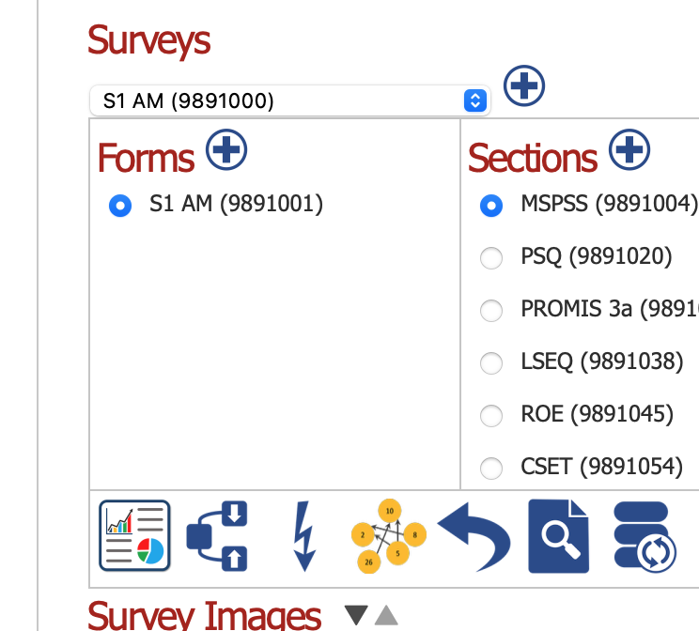

  - Click on the “Rapid Report” icon, and in the window that pops up, click on the “Generate Report” button in the lower left. That will return you to the previous screen with an additional button now available:
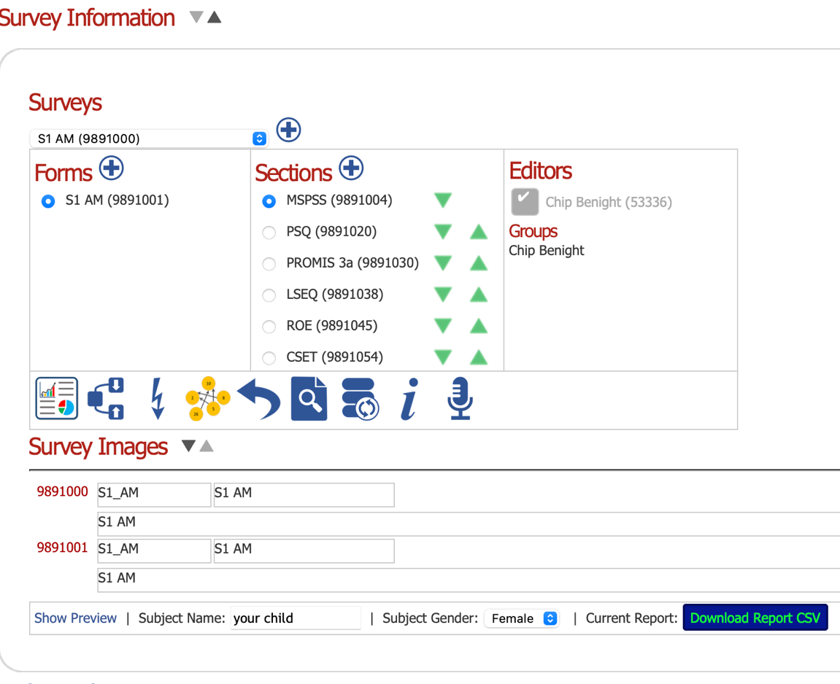
  - Click on the blue “Download Report CSV” button in the lower right.

- Repeat this process for each of the 12 surveys. If the data are not downloaded to the correct folder, move them to the correct folder now.

Download Audio Data

- We use “Bulk Media Download” to get the audio data from mEMA. After logging in, use the drop-down menu under “My mEMA” as shown in the following figure:
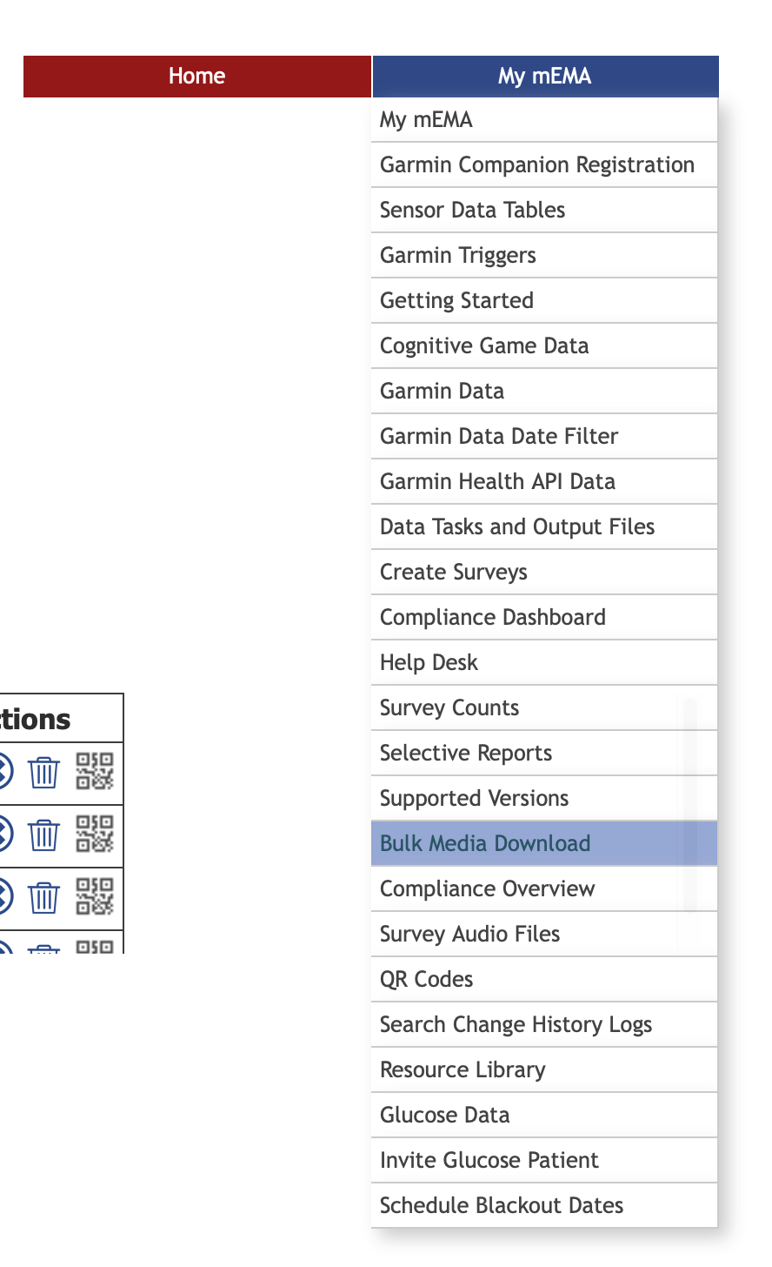

- That will take you to a page with this at the top (although the mobile codes you see may be different than the ones listed here):
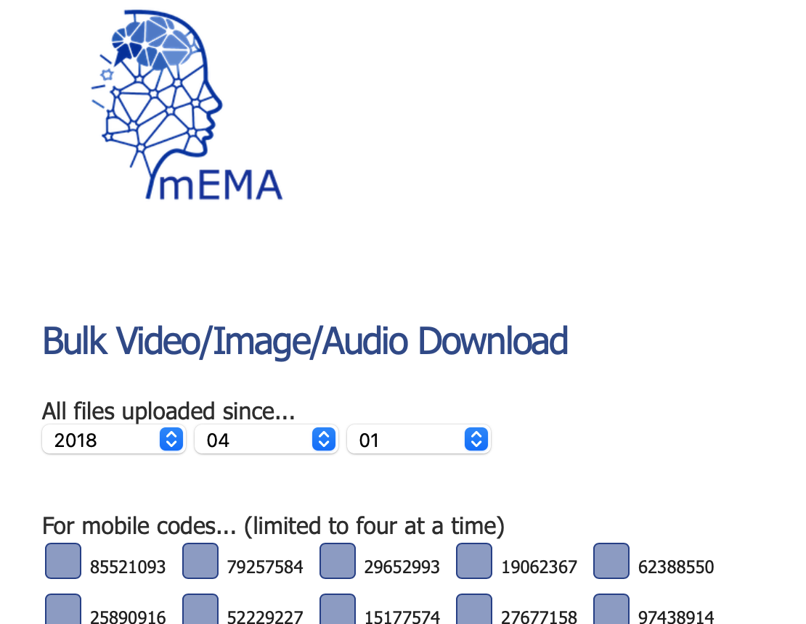

Scroll down to the bottom to see this (again, the mobile codes may vary):

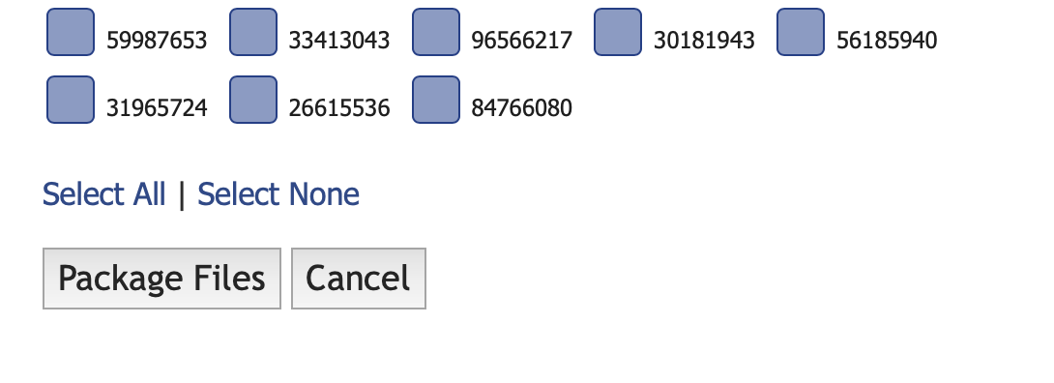
- Click on “Select All,” which should place a check mark next to every mobile code, and then click on “Package Files.” That will create the following option at the bottom of the page; note the new “Download Zip File” option:

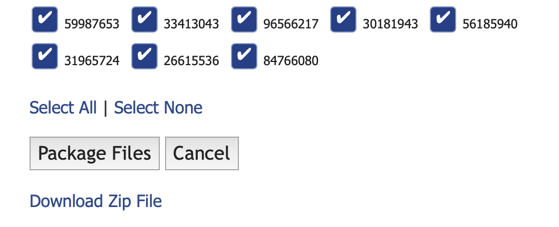
- Click on “Download Zip File” to download all of the mobile files. Save that file wherever you want.

- Unzip the downloaded file, which will create a folder containing multiple subfolders. Many of the folders will contain only one file, index.html, but some will have files with names like aud_*_*.3gp (where the asterisks are placeholders for several numbers). These are the audio files that we are looking for. You’ll see things like this:

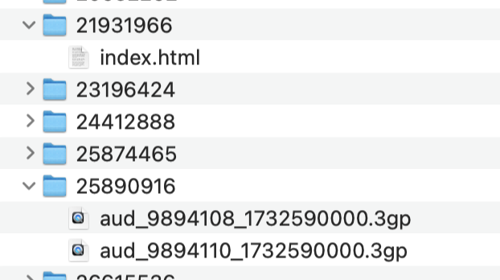

Don’t worry about the extra folders or files; the audio processing script will ignore them. (This procedure manual was meant to use as little human time as possible.)

- Move this folder to the appropriate audio folder.

- Log out of mEMA and close your browser window.

Update Code Linkages

In the UCCS SharePoint folder Lyda Hill Research | Documents | Research | Benight Lab | IRIS | Participant Tracking | Participant Study Progression, open Participant Tracker.xlsx. Also, open the file ~/IRIS_Data/IRIS Codes.csv. The latter file has three columns – rsp_id, mbl_cod, and IRIS_id – and you should use the data in Participant Tracker.xlsx to update those three columns. (I use copy and paste; this is difficult to automate because of the security of SharePoint files.)

Save that file and also copy it to the Data folder where the analyses are performed.

Wrangle EMA and Fitbit Data

Begin by copying (NOT moving!) the contents of the ema and fitbit_data folders into the Data folder where the analyses will be performed. That folder, Benight – IRIS for my machine, should have this folder structure:
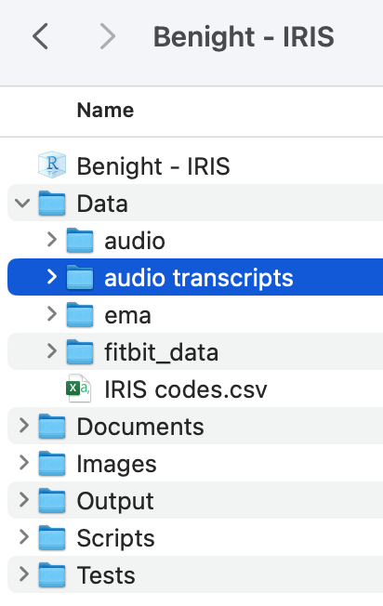
The Documents and Tests folders are optional; BPR uses the former for storing project-related documents (e.g., the NSF submission, literature to read, this file) and the latter for testing scripts before finalizing them. You may also see other files here, depending on your previous actions.

Three of the Data subfolders – audio, ema, and fitbit_data – are copied directly from the IRIS_Data folder. The other Data folder, audio transcripts, is created during the first part of audio file processing. (See below.)

Double-click on the Benight - IRIS file to start RStudio. (The extension of that file is .Rproj and it is an “R Project” file.)

The Data Prep.Rmd script can be found in the Scripts folder. That script should be run in its entirety to prepare the data. The script will create two compressed data files in the Data folder, labeled as EMA Data.RData and Fitbit Data.RData – that will be used in analysis.

Currently (2025-08-12), the Fitbit.RData file contains only the heart rate data from the Fitbits.

Audio Processing

Audio processing consists of two parts. The first part needs to be done only once. The second part is done whenever new data become available.

The audio subfolder will have all the audio data (your numbers may differ):
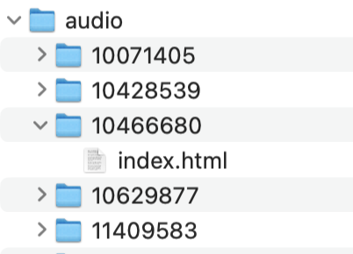

Start RStudio by double-clicking on the .Rproj file; this will allow the scripts to find the appropriate folders.

Go to the Files tab in the Files pane in RStudio, navigate to the Scripts folder, and open Audio Transcripts.Rmd. Run this file to process everything.

Currently, it processes all the data, which takes about 3 minutes per participant. Therefore, it will need to be shortened to accommodate incremental updates (i.e., new data). (Working on that…and also on renaming list elements using the IRIS designation rather than the mobile code.)

The list of audio data is stored as Transcript Data.RData in the Data folder. When loaded, this file creates an R object named transcript_list. Each list element corresponds to one of the mobile codes; each element within that list corresponds to one audio recording. These can be accessed like this:

To access mobile code number 87714946, recording aud_9891105_1750255200.3gp

use the R code:
transcript_list[[″87714946″]][[″aud_9891105_1750255200″]]

Nota bene: Be very careful copying and pasting the R code above: The quotation marks are almost certain to be incorrect, so you will probably have to manually replace them with the proper straight quotes in your R code!

